Current Revision:
01
Approved by:
Student Affairs Committee

Document Owner:
Student Activities Officer

Campus Alcohol Policy

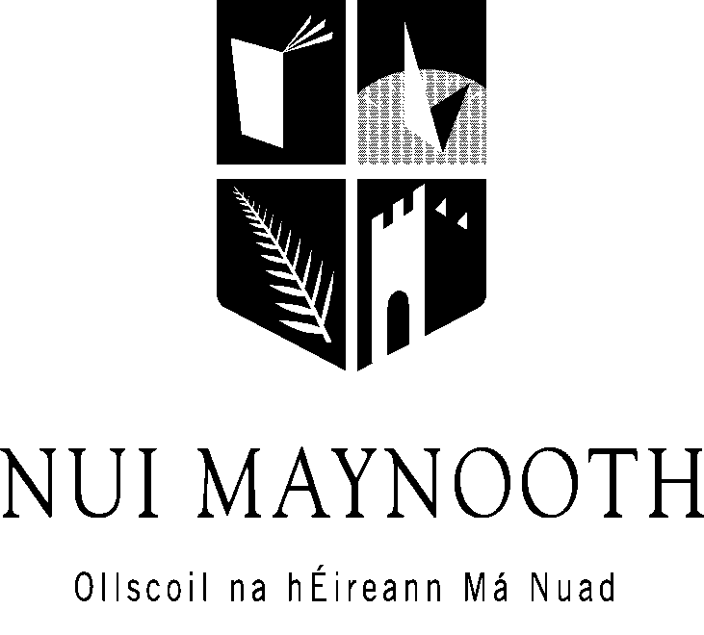

December 2009

1. INTRODUCTION

The University, recognising the place of moderate alcohol consumption in many areas of society, considers it important to create an environment within the University which promotes a sensible attitude to drinking, while accepting the potential of alcohol abuse to adversely affect the well-being of individuals.

2. BACKGROUND

The National Alcohol Policy, published in 1996 by the Department of Health, aims to promote the health of the population by reducing the prevalence of alcohol-related problems. One of the actions called for in the policy was the development of a campus alcohol policy that would promote sensible drinking among students and limit campus-related drinks industry sponsorship.

At that time, University and College authorities had expressed concerns about alcohol promotion practices on campus, high-risk drinking among students and the impact of this drinking pattern on student academic achievement, student personal problems and student attrition. An initial response to these concerns was discussed among a small number of third level institutions regarding a code of practice for the promotion of alcohol on University campuses. Further impetus was provided at the time by the Minister of Health and Children, Micheál Martin, at the launch of a three year Alcohol Awareness Campaign when he invited and encouraged all third level institutions to develop guidelines and campus alcohol policies and offered to facilitate the process.

As part of this process, NUI Maynooth adopted a campus alcohol policy. The policy aimed to address concerns about the promotion of alcoholic drink on the campus and the damaging effects of excessive consumption by students of the University. This policy resulted in a number of significantly positive changes, including elimination of promotions and advertising of alcohol by Clubs, Societies and the Students’ Union and the provision of alternative social and recreational options.

The policy outlined below is the result of the University’s deliberations and is part of a broader approach to health on campus, The Health Promoting University. This approach, with its origins in the WHO “Health for All” programme, advocates that Universities, as well as fulfilling their educational function, should also adopt the role of encouraging and promoting good health practices for the entire University community. This is achieved by not only addressing specific educational needs of individuals, but also by bringing about changes at institutional, community and policy levels.

3. RATIONALE

3.1 Public Health Alcohol Policy

The public health or health promotional perspective on alcohol problems, which provides the theoretical rationale for the alcohol policies proposed in this document, is perhaps best understood through comparison with the disease concept of alcoholism. The disease concept, prevalent in the 1950’s and 1960’s, viewed alcoholism as a specific or discrete disease, which was primarily explained in terms of individual vulnerabilities or predispositions, rather than to any negative properties of alcohol per se. Over the last three decades the public health approach, endorsed by the World Health Organisation, has emerged with the weight of evidence-based scientific research. This approach recognises alcohol as contributing to a spectrum of health, behavioural and social problems in terms of its toxicity, its potential to create dependency and its negative impact on human behaviour. It sees consumption levels and drinking patterns as being highly predictive of the incidence and prevalence of problems in any given society or social group. Acute alcohol–related problems, such as accidents, violence, injuries and deaths, are linked to excessive drinking on any one occasion. In many cases these problems occur among light and moderate drinkers who engage in heavy drinking on some occasions.

3.2 University Environment

At all Universities and Colleges, diversity of opinion and freedom of choice have long been part of the academic tradition. However, freedom of choice brings with it personal responsibilities which include the obligation to respect the rights of others and to comply with the University rules and regulations.

The ethos of the University not only promotes positive learning experiences and academic excellence, but also provides a caring and supportive community where students and staff in need of assistance are given the necessary supports. The University is also obliged to provide a safe working environment for all students and staff. Any activity or practice that constitutes a hazard must be eliminated or minimised to reduce injury or loss. When students engage in high-risk drinking, academic performance, health, personal relationships and safety suffer. However, alcohol issues cannot and should not be tackled in isolation and must be seen within a broader context of lifestyle issues and a supportive University environment.

3.3 Student Life

The period of late adolescence and early adult life is a transitional phase for students where new freedoms, new relationships and adapting to a different environment provides daily challenges, in addition to the academic challenges of new courses (Healy et al., 1999). Socialising is an important aspect of University life for students and the University Bar is one of the recognised contexts for meeting friends.

However, the cost of socialisation can over-stretch students both financially and academically which can contribute to exam failure and student drop-out (Canavan, 1999; O’Malley & Doran, 2001). First year students are particularly vulnerable and may have poor coping skills for managing the stresses of the new environment. This can lead to a range of negative reactions including an over-reliance on alcohol (O’Malley & Doran, 2001).
While exam stress and difficulties adjusting to University are common problems for students, there is also a clustering of problems for a minority of students. This stage of life is also characterised by vulnerability to many mental health problems, all of which may be exacerbated by heavy alcohol consumption. Problems with alcohol can also be linked to problems in other areas, such as problems with relationships, depression, difficulties with exams and financial problems (Canavan, 1999). For these reasons, an effective alcohol policy is an important part of a University’s retention strategy and any scheme of actions to improve the quality of student life.

The national lifestyle survey (SLÁN, 1999) shows the vast majority of young adults consume alcohol, half of young people engage in high-risk drinking when they typically drink and about one-third drink over the recommended sensible weekly limit. There is also a higher prevalence of serious injuries among young male adults relating to sport, work, and car / bike. The high-risk drinking pattern has also been found in local student surveys as well as the later the College Lifestyle and Attitudinal National Survey (CLAN 2002 /03) which also identified some worrying trends in the drinking culture of students.

4. Aims of a University Alcohol Policy

4.1 The aims of the NUIM Alcohol Policy are to:

- Ensure that the social and academic life on campus is conducive to the health and well being of students;
- Ensure that the University environment is safe for students and complies with health and safety regulations;
- Promote the University as a supportive environment that enables students to make healthy choices that promote health and well-being;
- Provide supportive services for those who may require assistance during their time at University.

4.2 The specific objectives include:

- Promoting the health and well being of students;
- Promoting personal responsibility and social obligation to the University community;
- Promoting low-risk drinking and discouraging high-risk drinking;
- Enhancing a campus environment where low-risk drinking is the “social norm”;
- Providing an atmosphere free from pressure to drink for those who choose not to drink;
- Providing alcohol-related information and education for all students;
- Supporting and promoting alternatives to drinking, thus creating choice and a balanced social programme;
- Promoting opportunities for brief interventions to reduce high risk drinking;
- Promoting a caring environment for those who experience difficulties related to alcohol;
- Providing confidential and effective supports for those who seek assistance as a result of problem drinking;
- Reducing the incidence of alcohol-related problems among University students.
4.3 Review and evaluation

The Student Affairs & Equality Committee, or an appointed Sub-committee thereof, will ensure that the plan of action is implemented and that there is a forum to receive feedback. A communication strategy that talks and listens to students is essential. Awareness of issues, successes and barriers are crucial in a student population in a constant state of change with a new intake each year. Evaluation of the stated objectives needs to be undertaken on a bi-annual basis, with a major policy review, to include a survey of drinking behaviour and attitudes, every four years to ensure a relevant policy.

5. POLICY MEASURES – An Integrated Approach

NUIM has chosen an integrated approach, with policy measures which encourage those who drink to do so responsibly thus moderating the demand for alcohol, and on the supply side to prevent commercial interests from excessive alcohol promotion. The five policy areas are:

• Increasing awareness and education;
• Encouraging alternatives and choice;
• Providing campus support services;
• Controlling marketing, promotions and sponsorship; and
• Limiting harm in the drinking environment.

5.1 Increase Awareness and Education

Students, faculty and staff are expected to be responsible for their actions at all times and respect the rights of all members of the campus community.

The University community will promote ‘low risk drinking’ behaviour and increase awareness of the potential harmful or negative effects of excessive alcohol consumption.

“Student Orientation” will be utilised as an opportunity to raise awareness of available programmes and services for all students and to promote a message of low risk drinking as well promoting the message that it is okay not to drink alcoholic drinks.

Opportunities will be sought to actively involve the student body in the development, promotion and delivery of an educational programme on alcohol consumption and related issues.

5.2 Encouraging Alternatives and Choice

The University will continue to materially support the maintenance and development of attractive alcohol-free environments on campus.

Under Club Licensing Law, students under 18 years of age are not admitted to the Students Union Club in the evening (after 9.30 pm). The capacity of the Club is also limited.

The Students Union will develop and promote alcohol-free programmes involving cultural, social and entertainment activities for students.

5.3 Provide Campus Support Services

Student support services will continue to develop ways to increase awareness of high-risk drinking among students availing of University services.

Individuals with concerns about their own use or another person’s use of alcohol will be encouraged to seek confidential assistance on or off campus.

The University will assist individuals or groups who wish to establish self-help groups on campus.

5.4 Controlling Marketing, Promotions and Sponsorship

The University has an obligation to provide a positive educational experience for all students as well as a safe working environment for students and staff. Therefore, NUIM affirms its role in providing a supportive environment for the University community, by identifying a clear set of guidelines on alcohol promotions and sponsorship. These are as follows:

5.4.1 Sponsorship

- A proactive approach by the University will be pursued as a top priority, to help student organisations find an alternative to drinks companies sponsorship;
- Sponsorship by the drinks industry of University events is permissible provided the sponsorship is in monetary form and not material form, thus allowing groups, clubs and societies to determine their own needs;
- The appointment of on-campus representatives by the drinks companies is prohibited;
- Alcohol sponsorship is not compatible with the sports and athletics ethos. It links alcohol use with the healthy pursuit of physical activity, and could be used as a way to circumvent the national advertising codes which prohibit the linking of alcohol with enhanced physical performance. Sports clubs will seek alcohol free sources of sponsorship.

5.4.2 Alcohol Promotions

- Alcohol promotions that encourage the rapid and/or excessive consumption of alcohol are prohibited on campus. Such promotions include “Happy Hours”, free drinks, 2-for-1 offers;

- Alcohol in bulk, such as kegs, cases of beer etc, will not be provided as free awards, prizes or rewards to individuals or groups. Student clubs and Societies are not permitted to accept such offers.

- The University will encourage off-campus drinks industry suppliers (bars, clubs and drinks representatives) not to engage in alcohol promotions, which result in high risk drinking among students.

- Agencies external to the University are not permitted to advertise or promote on the campus without the permission of the University, and then only in accordance with the terms of this policy, or other terms defined by the University.
5.4.3 Advertising Code

- Alcohol advertising on campus will be limited to brand name only, i.e. “Sponsored by Heineken” etc;
- Advertising of social and entertainment events will not use alcohol as the inducement to attend;
- Advertising posters will not encourage excessive use or high-risk drinking or place emphasis on quantity and frequency of alcohol use.

6. Local Support Services

Expertise and services in the local community can help play an important role in implementing the University Alcohol Policy. Such services include the Health Service Executive (HSE) with expertise in drug education, health promotion and treatment services, the Garda Siochána (especially the community liaison officers) and social welfare services. Opportunities for partnerships with these agencies will be encouraged.

7. Student Organisations

Students and student organisations also have responsibilities to ensure that the health of students, their ability to work, and the environment and the community life of the campus are not impaired by the abuse of alcohol.

Students drinking alcohol on campus are expected to use alcohol in a responsible manner. Their use of alcohol must not impinge on other people’s ability to enjoy the use of the facilities. Excessive drinking may not be used as an excuse for behaviour which contravenes the University’s Disciplinary Code.

Clubs, Societies or other student groups who wish to organise receptions or functions involving alcohol must adhere to the following guidelines:

- If free alcoholic drinks are available at any function, free soft drinks must also be provided;
- No more than two free drinks must be made available to any member;
- Advertising for events must not over-emphasise the availability of alcohol.

Availability of alcohol in on-campus licensed premises:

- If free alcoholic drinks are available at any function, free soft drinks must also be provided;
- No more than two free drinks must be made available to any member;
- Advertising for events must not over-emphasise the availability of alcohol.

Staff working in the campus bar must undergo training in the promotion of responsible drinking.

8. Breaches of Alcohol Policy

Breaches of the NUIM Alcohol Policy will be addressed using the University’s Disciplinary Code.

